

|  |
| --- |
| SALES REPORT |
|  |
| February 9  Authored by: Manish Chaudhary |

**Sales Data Analysis Report**

|  |
| --- |
| **1. Overview** This report provides an analysis of sales data, highlighting key trends, top customers, best-selling products, and monthly sales performance. The goal is to extract meaningful insights for business decision-making. |

## **2. Total Sales Overview**

* **Total Revenue:** $10,032,628.85
* The dataset covers multiple transactions across different products and customers.

This report provides an analysis of sales data, highlighting key trends, top customers, best-selling products, and monthly sales performance. The goal is to extract meaningful insights for business decision-making.

## **3. Top 5 Customers by Revenue**

These customers generated the highest revenue:

1. **Euro Shopping Channel** → $912,294.11
2. **Mini Gifts Distributors Ltd.** → $654,858.06
3. **Australian Collectors, Co.** → $200,995.41
4. **Muscle Machine Inc** → $197,736.94
5. **La Rochelle Gifts** → $180,124.90

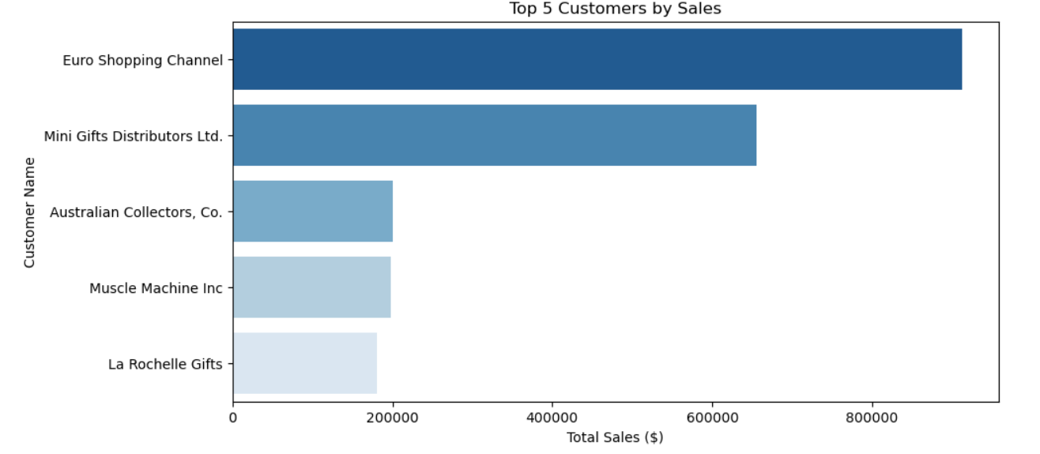

**Insight:** The top 5 customers contribute significantly to total sales, indicating a need to maintain strong relationships with them.

## **4. Most Sold Products**

The top-selling product lines (by quantity ordered) are:

1. **Classic Cars** → 33,992 units
2. **Vintage Cars** → 21,069 units
3. **Motorcycles** → 11,663 units
4. **Trucks and Buses** → 10,777 units
5. **Planes** → 10,727 units

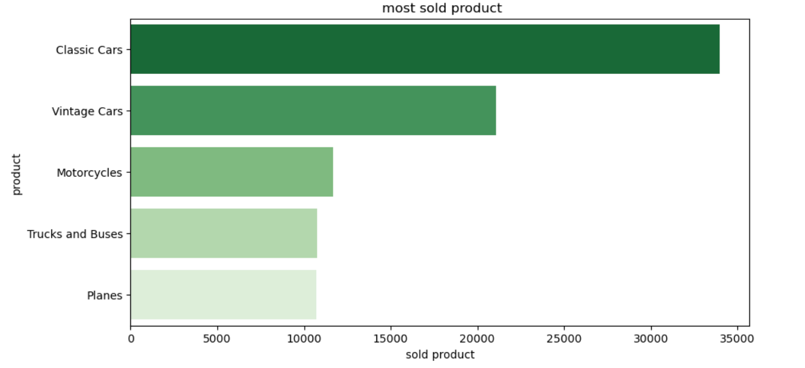

**Insight:** Classic Cars and Vintage Cars dominate the sales, suggesting a focus on marketing and stock availability.

## **5. Sales Trends Over Time**

Monthly sales trends show how revenue fluctuates across different periods:

|  |  |  |
| --- | --- | --- |
| Year | Month | Sales ($) |
| 2003 | Jan | 129,753.60 |
| 2003 | Feb | 140,836.19 |
| 2003 | Mar | 174,504.90 |
| 2003 | Apr | 201,609.55 |
| 2003 | May | 192,673.11 |
|  |  |  |

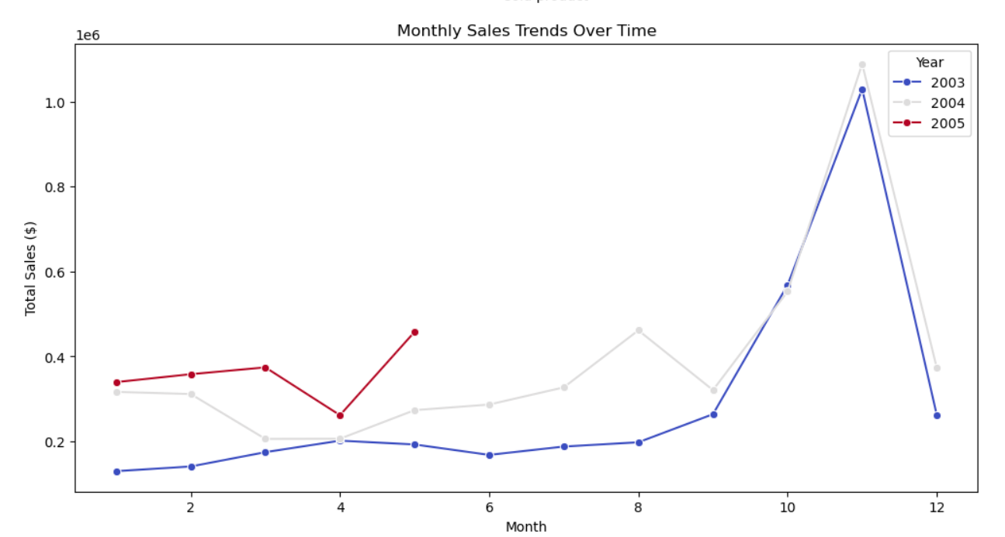**Insight:** Sales generally increase in Q2, possibly due to seasonal demand. This can help in planning inventory and promotions.

## **6. Key Recommendations**

1. **Customer Retention:** Prioritize top 5 customers through loyalty programs.
2. **Product Focus:** Invest in marketing and stock management for Classic and Vintage Cars.
3. **Seasonal Planning:** Align promotions with high-sales months to maximize revenue.
4. **Data-Driven Decisions:** Regularly monitor sales trends to adjust business strategies.

## **7. Conclusion**

This analysis provides a strategic view of sales performance, offering actionable insights for optimizing revenue growth. Further analysis can focus on customer purchasing patterns and regional sales performance.

**Prepared By:** Manish Chaudhary   
**Date:** 02/09/2025